**Daily Routine for Gestational Diabetes**

**Fasting Glucose Test**

**No food or drink before testing please. You should not have eaten for at least 8 hours.**

 C:\Users\dell\AppData\Local\Microsoft\Windows\Temporary Internet Files\Content.IE5\2FJWJY0O\MC900371340[1].wmf 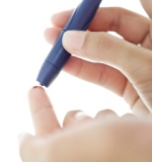 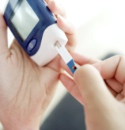 

Wake Up Wash & dry hands Prick the finger Test blood Write in book

|  |
| --- |
| * **Try to eat your meal within 30 minutes** * **No more carbohydrate foods before your 2 hour glucose test** |

**Breakfast**  C:\Users\dell\AppData\Local\Microsoft\Windows\Temporary Internet Files\Content.IE5\18FBX170\MC900412630[1].wmf

**2 hours after the start of breakfast test your glucose level**

C:\Users\dell\AppData\Local\Microsoft\Windows\Temporary Internet Files\Content.IE5\2FJWJY0O\MC900371340[1].wmf 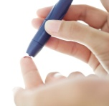 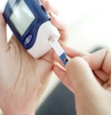  C:\Users\dell\AppData\Local\Microsoft\Windows\Temporary Internet Files\Content.IE5\072G75NT\MC900234478[1].wmf

Wash & dry hands Prick finger Test blood Write in book Morning snack

e.g. fruit,milk or yogurt

|  |
| --- |
| * **Try to eat your meal within 30 minutes** * **No more carbohydrate foods before your 2 hour glucose test** |

**Lunch**  C:\Users\dell\AppData\Local\Microsoft\Windows\Temporary Internet Files\Content.IE5\18FBX170\MC900412630[1].wmf

**2 hours after the start of lunch test your glucose level**

**C:\Users\dell\AppData\Local\Microsoft\Windows\Temporary Internet Files\Content.IE5\2FJWJY0O\MC900371340[1].wmf 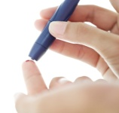 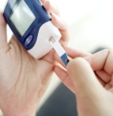  C:\Users\dell\AppData\Local\Microsoft\Windows\Temporary Internet Files\Content.IE5\18FBX170\MC900411900[1].wmf**

Wash & dry hands Prick finger Test blood Write in book Afternoon snack

|  |
| --- |
| * **Try to eat your meal within 30minutes** * **No more carbohydrate foods before your 2 hour glucose test** |

**Evening Meal**

C:\Users\dell\AppData\Local\Microsoft\Windows\Temporary Internet Files\Content.IE5\18FBX170\MC900412630[1].wmf

**2 hours after the start of dinner test your glucose level**

C:\Users\dell\AppData\Local\Microsoft\Windows\Temporary Internet Files\Content.IE5\2FJWJY0O\MC900371340[1].wmf  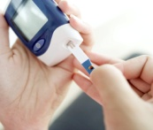  C:\Users\dell\AppData\Local\Microsoft\Windows\Temporary Internet Files\Content.IE5\BUSJCTLF\MC900215525[1].wmf

Wash & dry hands Prick finger Test blood Write in book Evening snack