|  |  |
| --- | --- |
| Screening and Diagnosis of Gestational Diabetes and Diabetes in Pregnancy |  |

Information for Clinicians

# Diabetes and pregnancy

According to the World Health Organisation (WHO), hyperglycaemia in pregnancy is a broad term to reflect abnormal glucose tolerance first detected at any time during pregnancy. It can be further classified as either diabetes mellitus in pregnancy, or gestational diabetes mellitus.1

When diabetes is detected at any time during pregnancy (in women previously not diagnosed with diabetes) using the 2006 WHO criteria,2 it is referred to as **diabetes in pregnancy (DIP)**, or “overt diabetes mellitus during pregnancy”*(see next page for diagnostic criteria).*

**Gestational diabetes mellitus (GDM)** refers to the diagnosis of diabetes in women (non-diabetic prior to pregnancy) in the early (<24 weeks) or mid-to-late stages (24-28 weeks) of gestation, based on the 2013 WHO criteria1 endorsed by the Australasian Diabetes in Pregnancy Association (ADIPS)3, 4 and the Royal Australian and New Zealand College of Obstetricians and Gynaecologists (RANZCOG)5 (*see next page for diagnostic criteria).*

The prevalence of GDM is higher than DIP. More than 17% of women who gave birth in an Australian hospital in 2020-21 were diagnosed with GDM.6 This rate is rising nationally and globally as risk factors including obesity and advanced maternal age increasingly complicate pregnancies.

This fact sheet outlines the screening and diagnosis of GDM & DIP only. For investigations and diagnosis of diabetes outside of pregnancy, please refer to the [Australian Diabetes Society- HbA1c for Diagnosis of Diabetes Mellitus guidelines (May 2023)](https://www.diabetessociety.com.au/wp-content/uploads/2023/05/Guidance-concerning-the-use-of-glycated-haemoglobin-for-the-diagnosis-of-diabetes-meliitus-Final-May-2023.pdf).

# Screening for GDM & DIP

Oral glucose tolerance testing (OGTT) is the current gold standard for diagnosing diabetes during pregnancy. The WHO1 and the ADIPS3, 4 recommend universal screening of all pregnant women at 24-28 weeks gestation. If the following risk factors are present, early screening around 13 weeks may be indicated.

### Risk factors for hyperglycaemia in pregnancy:7

• Previous hyperglycaemia within or outside of pregnancy

• Maternal age >35 years

• Ethnicity with high diabetes prevalence (e.g. Asian, Indian subcontinent, Aboriginal, Torres Strait Islander, Pacific Islander, Maori, Middle Eastern, non-white African)

• Family history of diabetes mellitus (first degree relatives)

• Pre-pregnancy BMI >30 kg/m2

• Previous macrosomia (birthweight >4,500 g)

• Polycystic ovarian syndrome

• Medications including glucocorticoids and antipsychotics

### OGTT is contraindicated in individuals with:

• Pre-gestational diabetes mellitus, i.e. known diabetes before conception

• A history of bariatric surgery

Individuals who have undergone bariatric surgery (e.g. gastric banding, sleeve gastrectomy, gastric bypass) should not be referred to OGTT as it can lead to common and serious side-effects of postprandial “dumping” syndrome and reactive hypoglycaemia.8 Alternative tests including HbA1c (in the first trimester) and glucose monitoring for 4-7 days (at any time during pregnancy) may help to diagnose GDM/DIP in patients who have previously undergone bariatric surgery.8, 9

# OGTT Protocol

Normal diet and carbohydrate intake should be maintained for three days prior to testing. Patients should fast overnight and drink water only.3, 10

A 75 g 2-hour OGTT is performed in the morning with three blood draws. A baseline fasting blood sample is obtained before 75 g of glucose is given as a drink. Patients remain seated for the duration of the test and blood is drawn again at 1 hour and 2 hours. Plasma glucose is then measured in all three samples.

For more information on patient preparation and the testing procedure, please see our [information sheet](https://pathology.health.nsw.gov.au/test_information/glucose-tolerance-test/).

# OGTT Results Interpretation

The following 2013 WHO OGTT diagnostic criteria have been endorsed by ADIPS and RANZCOG.

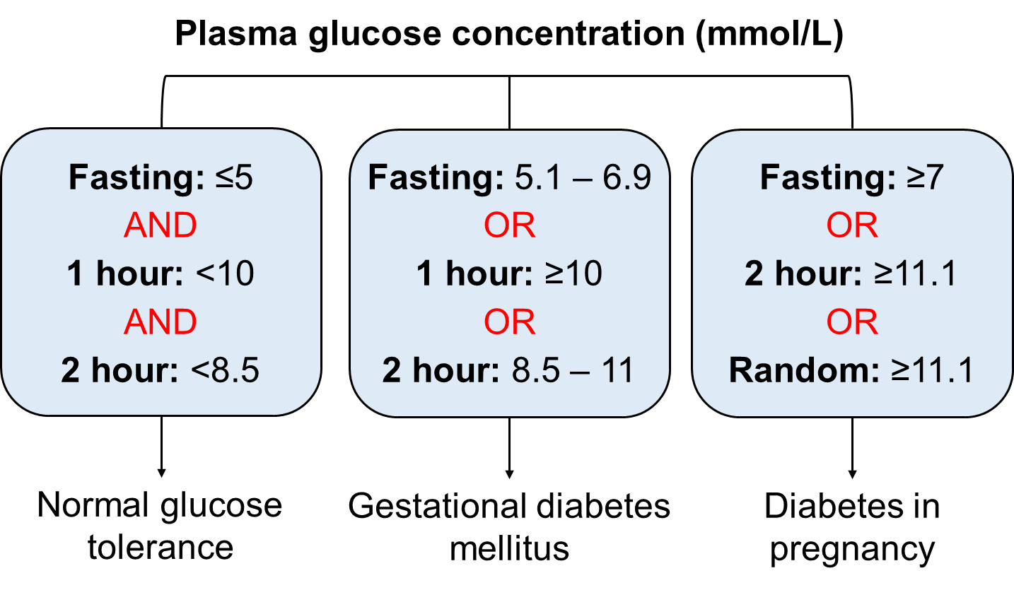

If the OGTT is diagnostic of GDM or DIP, specialist referral to a diabetes and obstetric team is recommended.

# Postpartum Follow-Up

Unless contraindicated, it is recommended that women diagnosed with GDM have a 75 g 2-hour OGTT at 6-12 weeks postpartum and be classified according to the following 2006 WHO criteria:2

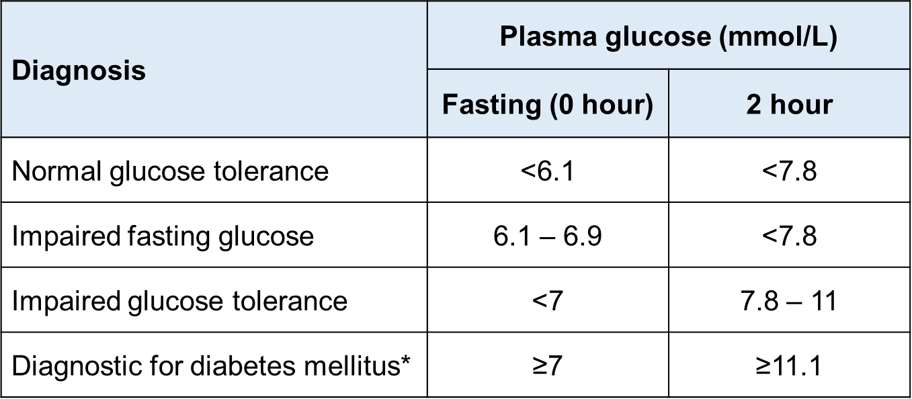

*In the absence of symptoms or unequivocal hyperglycaemia, this result should be confirmed with repeat testing or measurement of HbA1c.

Women diagnosed with GDM have an approximate 30% risk of developing hyperglycaemia in a subsequent pregnancy and their risk of developing type 2 diabetes is 1.5 – 10% per year.3 Regular surveillance including fasting glucose measurements, OGTT, and/or measurement of HbA1c is recommended. Frequency of testing is dependent upon individual risk.

# References

1. World Health Organisation. Diagnostic Criteria and Classification of Hyperglycaemia First Detected in Pregnancy. <https://apps.who.int/iris/handle/10665/85975>
2. World Health Organisation. Definition and diagnosis of diabetes mellitus and intermediate hyperglycemia. <https://apps.who.int/iris/handle/10665/43588>
3. Nankervis A, McIntyre HD, Moses R, Ross GP, Callaway L, Porter C, Jeffries W, Boorman C, De Vries B, McElduff A. ADIPS Consensus Guidelines for the Testing and Diagnosis of Hyperglycaemia in Pregnancy in Australia and New Zealand (modified November 2014).
4. Nankervis A, McIntyre HD, Moses R, Ross GP, Callaway L, Porter C, Jeffries W, Boorman C, De Vries B, McElduff A. ADIPS Consensus Guidelines for the Testing and Diagnosis of Gestational Diabetes Mellitus in Australia (modified June 2014: see point 3).
5. The Royal Australian and New Zealand College of Obstetricians and Gynaecologists. Diagnosis of Gestational Diabetes Mellitus (GDM). <https://ranzcog.edu.au/wp-content/uploads/2022/05/Diagnosis-of-Gestational-Diabetes-Mellitus-GDM.pdf>
6. Australian Institute of Health and Welfare. (2023). Diabetes: Australian facts. <https://www.aihw.gov.au/reports/diabetes/diabetes>
7. Sweeting A, Wong J, Murphy HR, Ross GP. A Clinical Update on Gestational Diabetes Mellitus. *Endocr. Rev.* 2022; 43(5):763-793.
8. Benhalima K, Minschart C, Ceulemans D, Bogaerts A, Van Der Schueren B, Mathieu C, Devlieger R. Screening and Management of Gestational Diabetes Mellitus after Bariatric Surgery. *Nutrients* 2018; 10(10):1479.
9. The Royal Australian and New Zealand College of Obstetricians and Gynaecologists. Management of Obesity in Pregnancy. <https://ranzcog.edu.au/wp-content/uploads/2022/05/Management-of-Obesity-in-Pregnancy.pdf>
10. Harmonisation of Endocrine Dynamic Testing-Adult (HEDTA). <https://www.rcpa.edu.au/getattachment/fc0f1dc9-dd9e-428b-a2bb-0caff0f9a70b/Harmonisation-of-Endocrine-Dynamic-Testing-Adult-(.aspx>

# More information

For further information, go to the pathology.health.nsw.gov.au website or visit our health information partner:

[](http://www.pathologytestsexplained.org.au)